Day 6

1. Edit functionality

* In the single card, we added the edit button

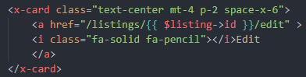

* Also created the routes and controllers



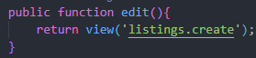

* This was get method all along



* Now we created edit blade file and then added the create blade full template doing some changes
* We cannot change the form method to PUT or DELETE

So Laravel has this for us



* Now instead of the old values we wanted the actual values which we can get by this code for all



* And for description we need to pass value inside of the tag



* For edit logo we put the image tag of earlier

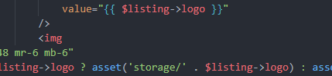

* And now created new route



* We copied the store and then changed some value including the Rule on same company



* And we changed this code



1. Delete functionality

* We first added the frontend with form

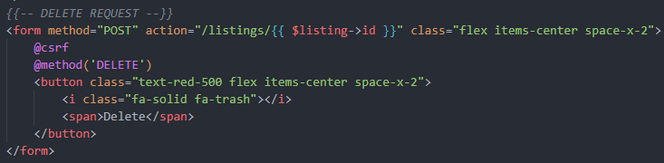

* Then defined the routes



* Then created the controller

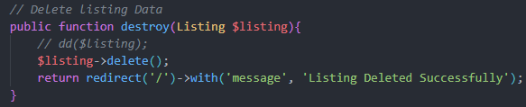

* AND EVERYTHING WORKS

1. User registration

* First we made user controller



* Then added the routes



* Then imported classes and changed the routes in the blade
* Now in the user controller we made the function 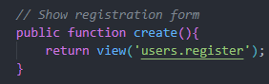
* And then added the layout component wrapper

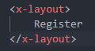

* Now we added the template and changed and added couple of thing such as



And error for every input

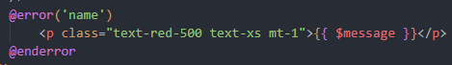

* Now we made route for creating new user



* We created new controller store function

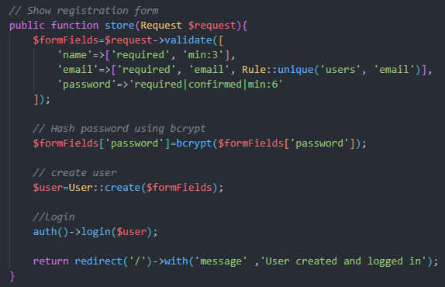

* There was an error in our migrations

Instead of  there was passed ‘user id ’ there causing error

1. Auth links

* So first we find the Navbar end in the layout
* Now we started auth helper

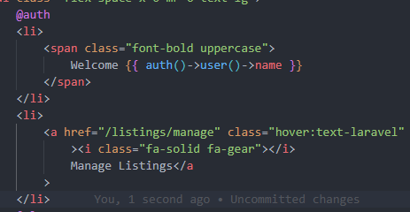

* Now else helper if user not logged in and end auth already

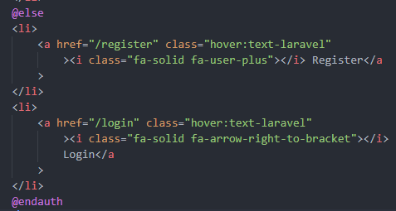

* And with this we get 

1. User logout

* We added the logout form in the code

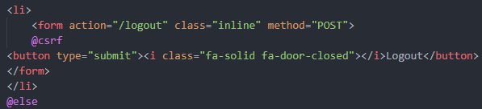

* Then we made route



* Then the controller

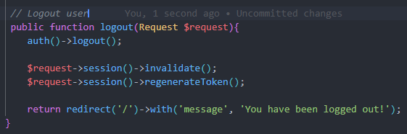

AND EVERYTHING WORKS